

**Distributed operating systems**

**A Multi-tier Online Book Store**

**Instructor:**

**Samer Arandi**

**Students:**

**Hala okal**

**Farah toqan**

**Introduction:**

In this lab we are required to design Bazar.com using two tier we design (front-end and back-end), also we are recommended to use a lightweight micro web framework. So, in our solution we use a Node JS frame work ,and we are use virtual machine for different server, so we build 3 virtual machines with ubuntu operating system, two of them used for the backend (order and catalog )tier and the third is(frontend), and we use a NAT network(which we created) to connect 3 machines with each other’s and with our device network which work in this case as a router, then when we want to test our microservices we will send it with the IP address for the device and the port that listening for the request.

In our program we have two files for data base one for store the catalog of books we have (catalog.csv), and the other for store the orders of users (order.csv).

**Procedure:**

How does the code run?

First, we run the 3 virtual machines.

Second, from the Frontend server, we put the link we want on the browser.

If we want to search for a book by name, like in this example we search about RPCs for Noobs book,we put the ip address and the port for the fronend server

http://10.0.2.15:4001/CATALOG_WEBSERVICE_IP/search/RPCs for Noobs

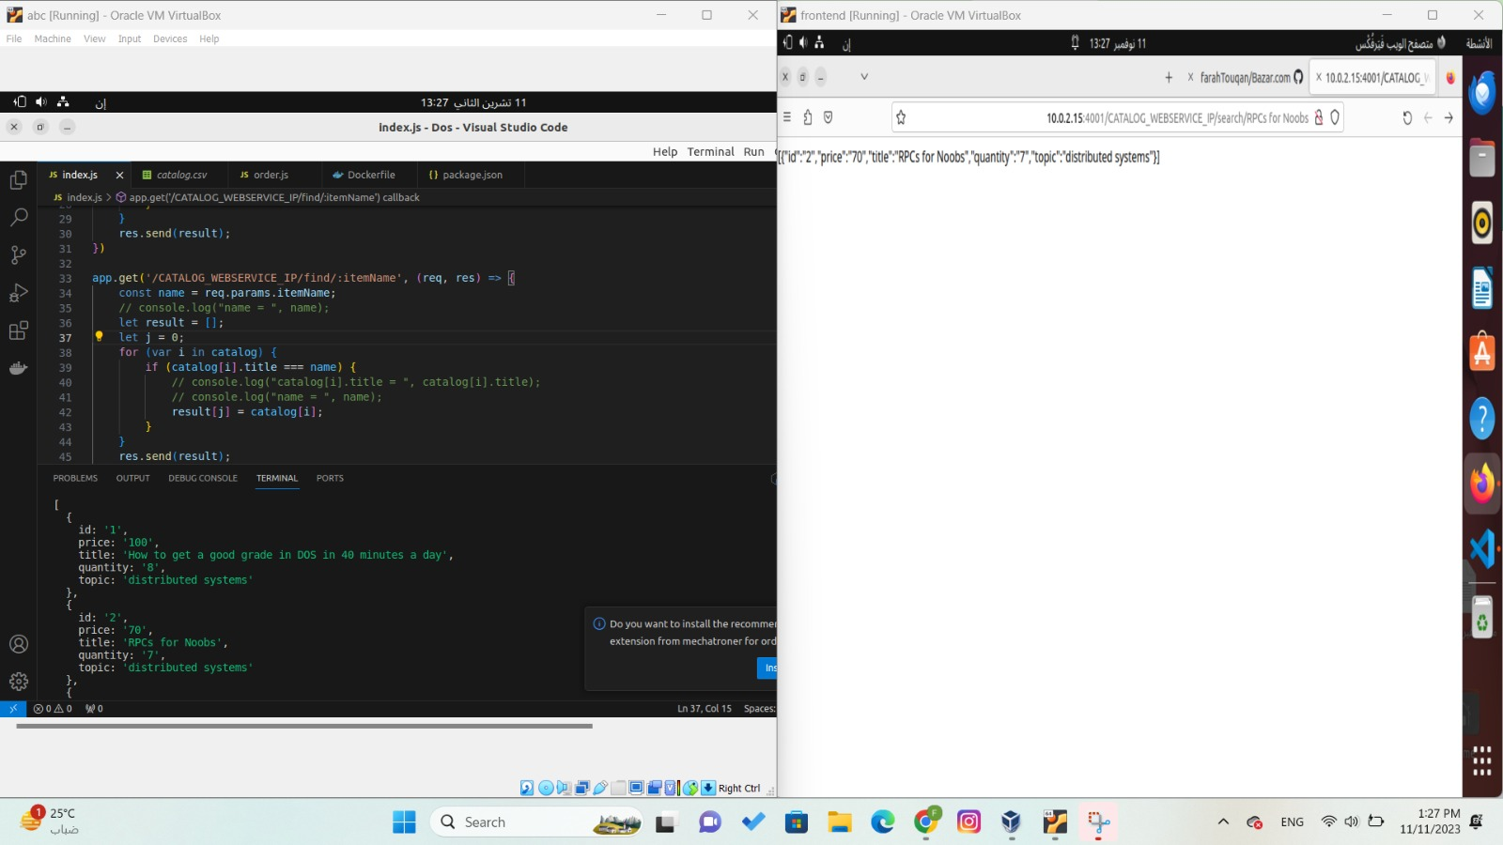

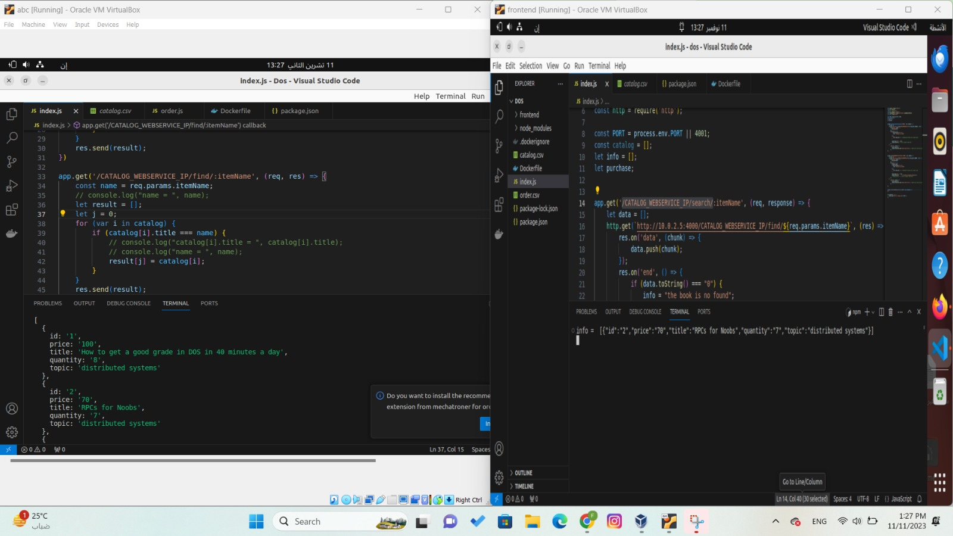

If we want to get information about a book by ID , like in this example we need to get information about the book that has an Id = 4 ,we put the ip address and the port for the fronend server

http://10.0.2.15:4001/CATALOG_WEBSERVICE_IP/info/4

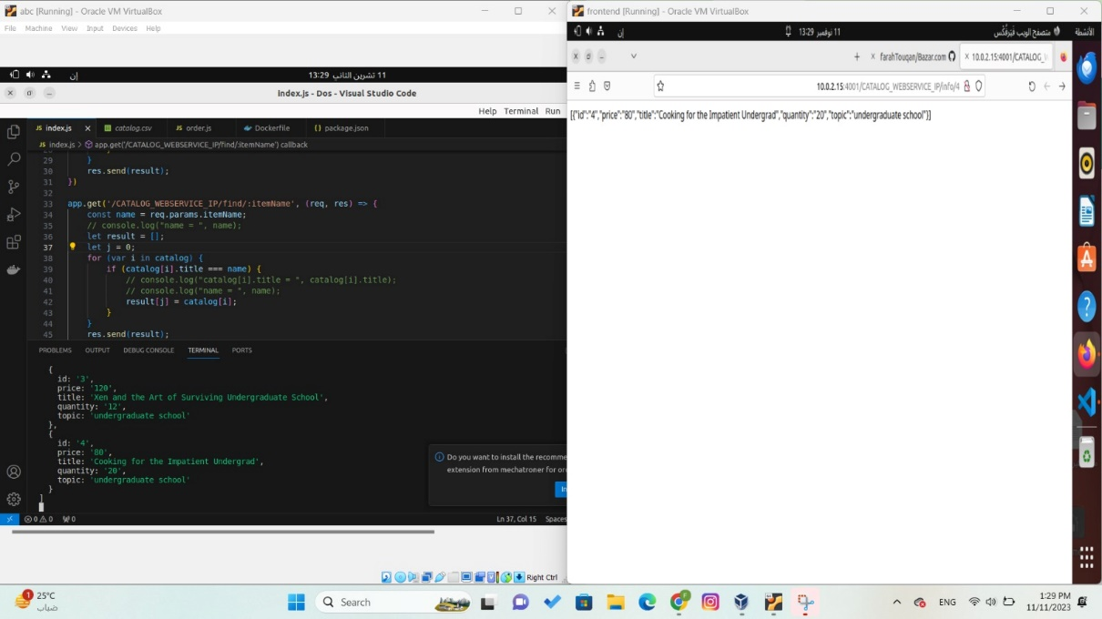

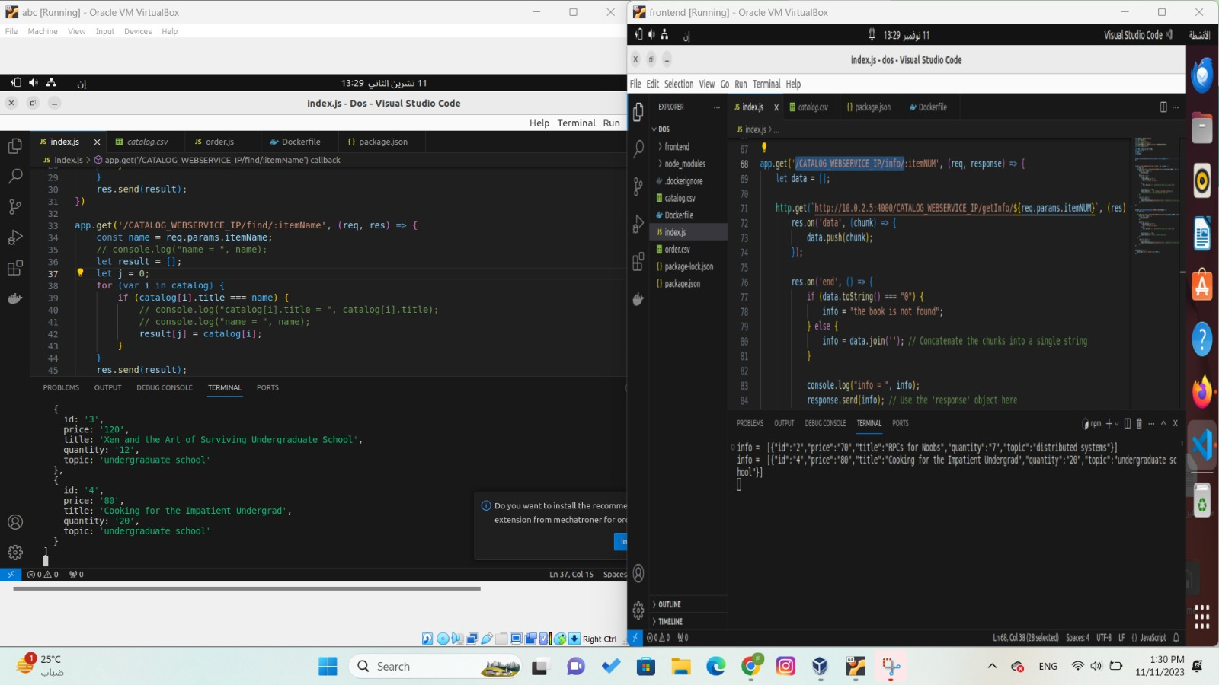

If we want to buy a book by ID , like in this example we need to buy a book that has an Id = 3 ,we put the ip address and the port for the fronend server

http://10.0.2.15:4001/CATALOG_WEBSERVICE_IP/purchase/3

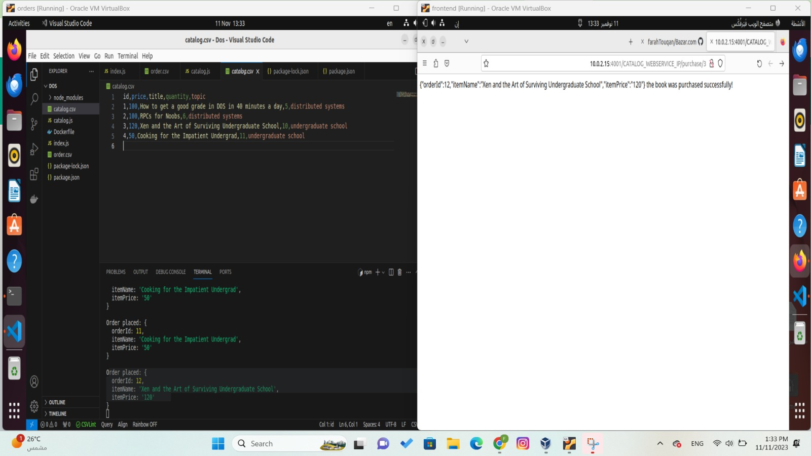

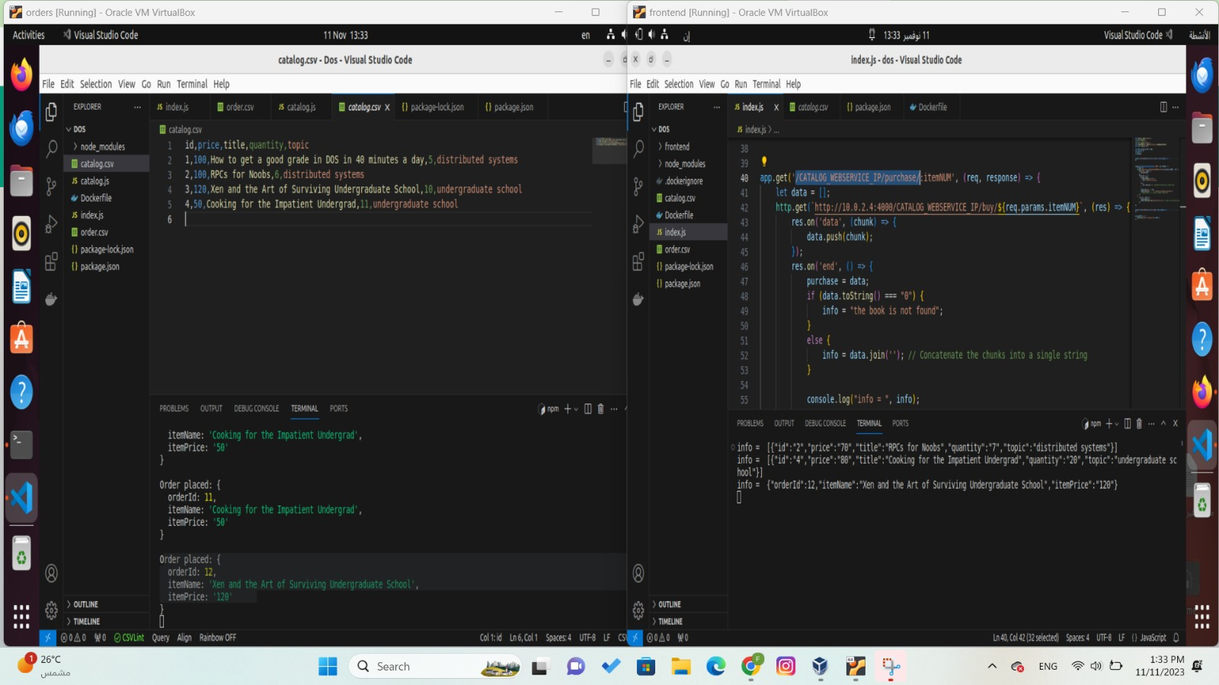

**Impr** **ovement:**

We can improve our program by send the quantity of how many books we will buy, that’s when we send a purchase in URL, we can send another number which consider of how many books we will buy.

It will be something like this:

CATALOG_WEBSERVICE_IP/purchase/2/3

which mean that we will buy 3 books from the book that have the id = 2.

Another improvement to my solution, I can use Joi library for testing and validation process.